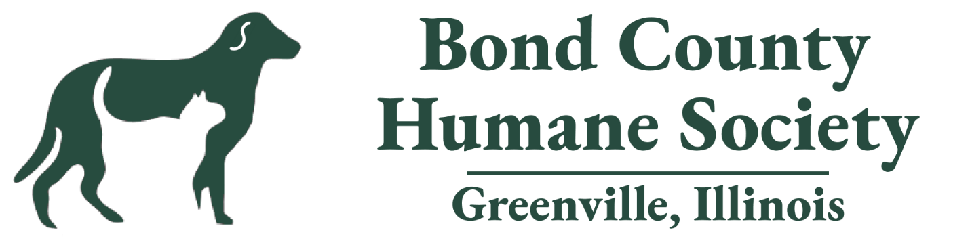

Paws in the Park 2025

Bond County Fairgrounds

Saturday, Oct.18

11 am to 3 pm

Sponsorship Levels

Labrador Retriever Level $500

* Business name on back of t-shirts
* Business names or logos will be presented in the designated areas for each event along with the business name on a trophy.
  + Best Kisser
  + Dog Pie Eating Contest
  + Fastest Fetch
  + Longest Down
  + Best Tricks
  + Cutest Pet Photo
  + Best Costume
  + Best Howler

Bulldog Level $300

* Dog Pie eating Contest
  + Signage with business names in that area
* Pet Parade Sponsors:
  + Signage with business names on parade route
* Cutest Pet Photo Contest
  + Signage with business names in that area

Chihuahua Level $150

* Booze Barrel, Silent Auction, Photo Booth, Drink sponsors
* Signage with Business names in those areas

# BOND COUNTY HUMANE SOCIETY

# 2025 PAWS IN THE PARK

# SPONSORSHIP FORM

Bond County Humane Society (BCHS) is a not-for-profit organization created to provide temporary housing to stray, neglected, abandoned cats and dogs until permanent loving homes can be found. Paws in the Park is an annual event with the goal of raising funds needed to provide housing, food and medical care to the animals rescued by BCHS. Your support is greatly appreciated.

Organization/Company Name: __________________________________

Contact Person: ________________ Title: ________________________

Street Address:______________________________________________

City: ____________________ State: _______ Zip Code: ___________

Phone: _____________________

My organization wishes to select the following sponsorship level to support BCHS:

◻ Labrador Retriever $500

◻ Bulldog $300

◻ Chihuahua $150

A description of Sponsorship levels is provided on the back of this form. Please call BCHS at 618-664-4068 with any questions.

Amount: $__________________________

All sponsorship requests and payments must be received by **October 1, 2025.**

Please mail to

Bond County Humane Society

2510 S Elm Street

Greenville, IL. 62246